Lab 7: Networking in AWS
AWS networking enables you to create secure, scalable, and reliable networks in the cloud, offering services like Amazon VPC for isolated networks, Direct Connect for dedicated connections, and CloudFront for content delivery.
Fundamental Networking Services:
- Amazon Virtual Private Cloud (VPC):
A logically isolated section of the AWS Cloud where you can launch AWS resources in a virtual network environment, giving you control over IP addressing, subnets, and gateways. Inside the VPC, you can create servers, databases, and other resources, and control who can access them.
- Subnets:
A range of IP addresses within your VPC, allowing you to segment your network into public and private subnets. Subnets are smaller networks inside your VPC. Imagine your VPC is a building — subnets are like rooms inside the building.
- Security Groups:
Virtual firewalls that control inbound and outbound traffic for your EC2 instances.
- NAT Gateway:
Allows EC2 instances in private subnets to access the internet without exposing them directly.
- CIDR (Classless Inter-Domain Routing):
CIDR just describes an IP range in the format IP_address/Prefix e.g 10.0.0.0/24 .
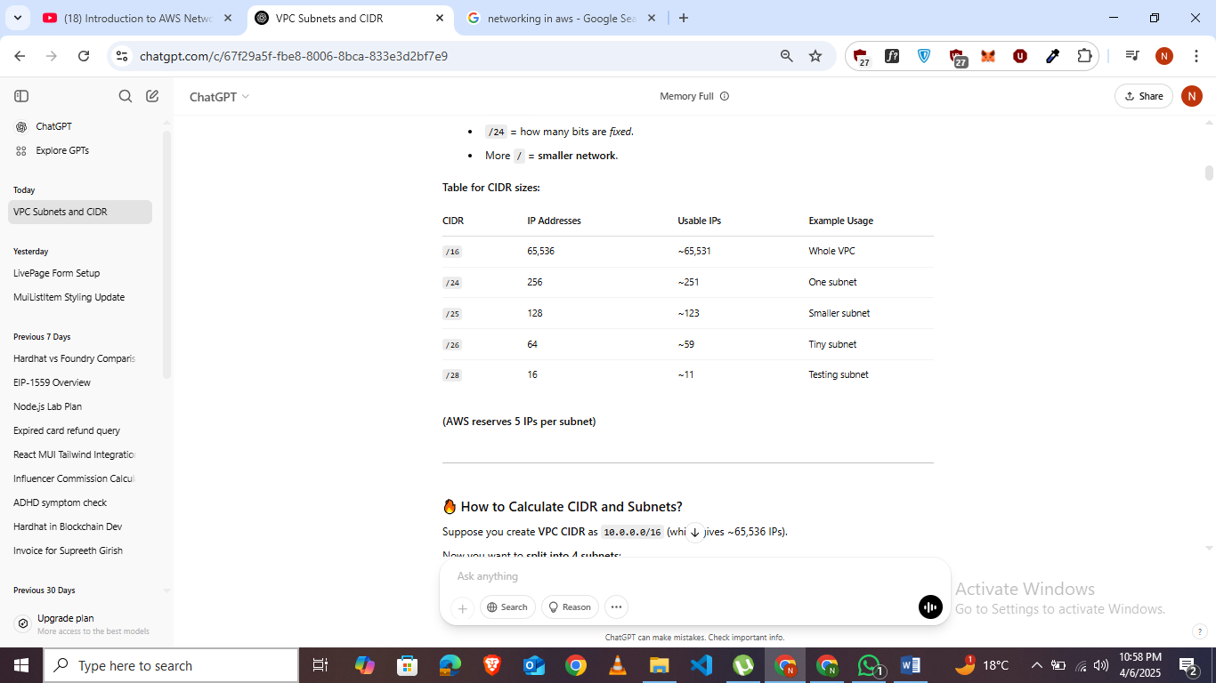
- Elastic Load Balancing (ELB):
Distributes incoming application traffic across multiple targets, such as EC2 instances, to ensure high availability and scalability.
- Route Tables:
Determine how traffic is routed within your VPC.
- Internet Gateway:
Allows VPCs to communicate with the public internet.
AWS VPC Overview:
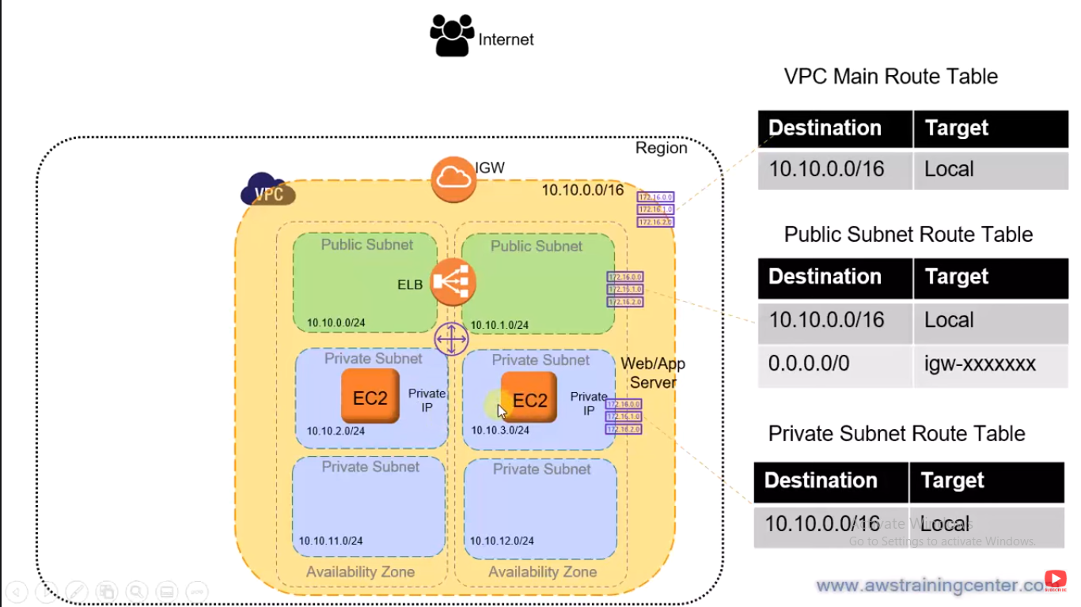
Creating VPC:
- Go To VPC dashboard and click on create a VPC.
- Manually Enter a CIDR in ipv4 and create VPC.
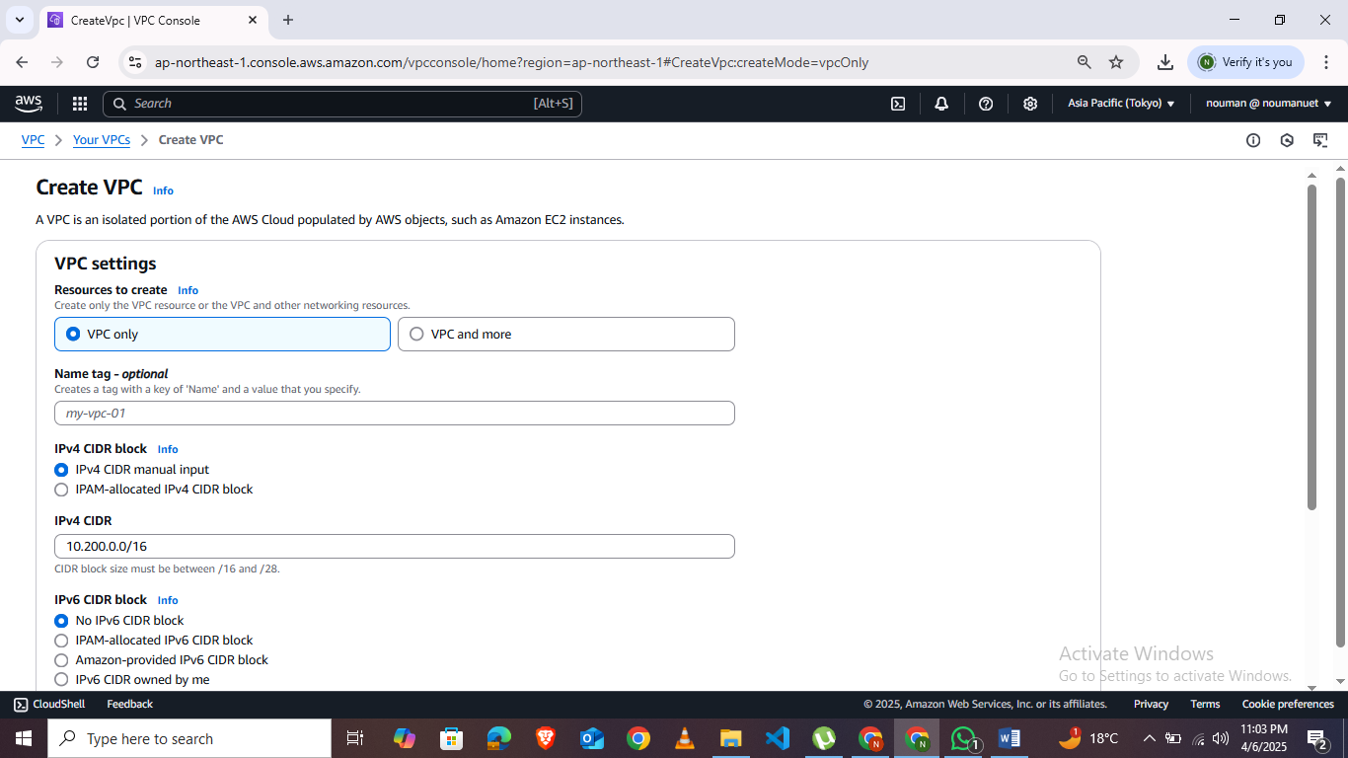
- Associate VPC with internet gateway by creating an Internet gateway and attach it to your VPC. 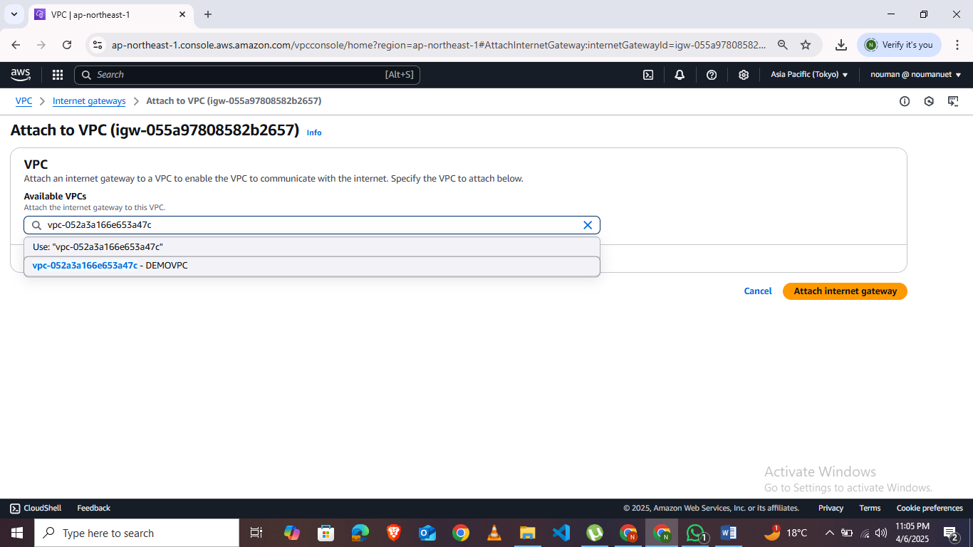
- Now Create Subnets . We will create private and public subnets.
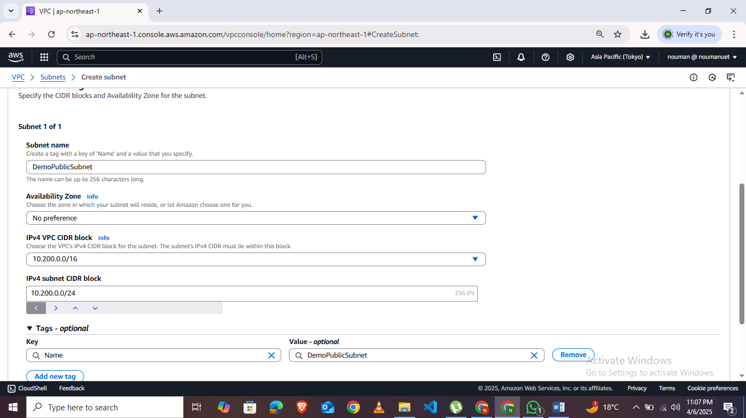
Repeat the same steps for private Subnet. Remember not to assign same subnet CIDR .
- Now Assign Route table to Public subnet by creating a subnet and in routes table add 0.0.0.0/0 in routes of the route table . Associate it with the public subnet. 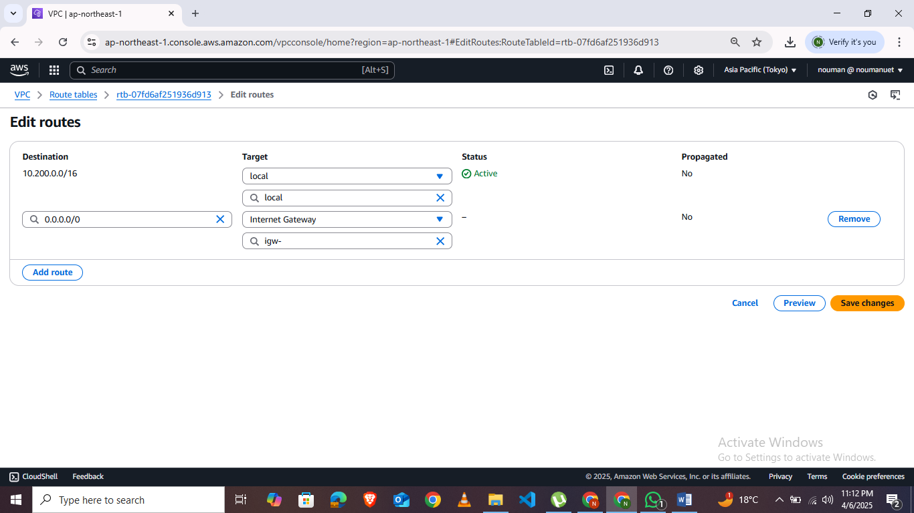
- Don’t add any routes for private route table .Only associate with private subnet. 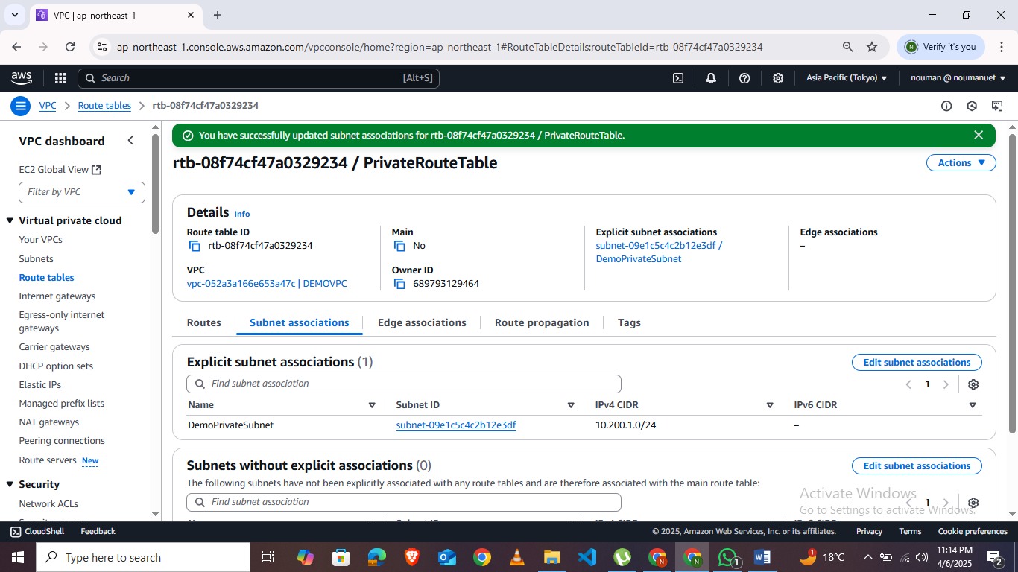
LAB TASKS:
- Create a custom VPC by your Name and Roll Number.
- Create public and private subnets in it.
- Attach internet gateway to it.
- Attack route tables to the public and private subnets.

